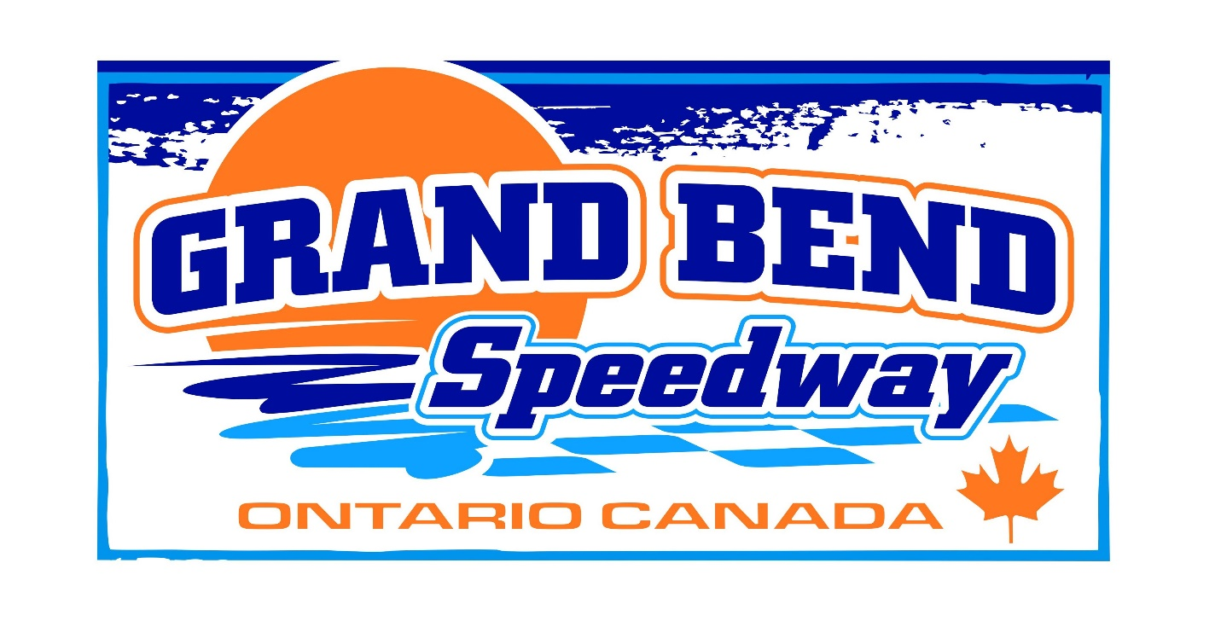North Coast Compact Challenge Rules

ENGINE Rule:
ENGINE and TRANSMISSIONS Four- or Six-cylinders engines only. No super or turbochargers are allowed. No chemical power adders of any kind (nitrous oxide, benzene, nitromethane, etc.) are allowed. Four-cylinder engines may be pushrod, SOHC, or DOHC. OEM stock variable cam timing is allowed on all four cylinders displacing 2.5 liters or less only. Maximum displacement is 2.5 on all four-cylinder engines. Six-cylinder engines must be SOHC or pushrod only. The maximum displacement for six cylinders is 3.5 liters. Cars must use an OEM engine type and brand matching the make of the car (Example: any Honda Civic engine in a Honda Accord is allowed). Cylinder heads must be a stock type casting for the engine type and original displacement used (Example: No aftermarket heads). No engine swaps of non-stock engine types from other makes or models of vehicles are allowed. (Example: A V6 truck engine in a Dodge Neon is not allowed). The throttle body must be attached to the intake manifold at the stock location. Single overhead cam cars will be allowed aftermarket intakes and dual overhead cam cars will have to run stock intakes for the engine make. No fabricated manifold plenums are allowed. No mixing and matching of VTEC heads/blocks. 16V max cam lift .500 8V max cam lift .550. 16V stock intake manifold, 8V any intake manifold. Headers allowed. Any Throttle Body Any Injector 350 CFM MAX CARB. No antifreeze.

Transmission:
Transmission must match chassis manufacturer

Exhaust:
3” max exhaust.

Weight Rule
SOHC 2150. DOHC 2250, 6 CYL FWD and K-Series 2450, Maximum Weight rule 2750.
55% Left Side Percentage FWD or RWD allowed

Width Rule:
73 inch width measured at the outside bead.

Tires:
Hoosier racing tires only 790 or 800 compounds.
No Tire Softener

Suspension:
Must use factory style suspension, no switching to 3 link/4 link/or dbl wishbone if not factory equipped
Aftermarket A-Arms permitted for camber adjustment
Lowering/Racing Springs Allowed
Coil overs Allowed, NO DAMPING ADJUSTMENT ALLOWED
Body Rules:
BODY All exterior trim, including lights, body moldings, mirrors, etc… must be removed. All cars are required to have a front bumper cover, hood, both front fenders, windshield, all doors, (2 or 4 depending on model) both quarter panels, deck lid (must enclose trunk area), and a rear bumper cover. Pillars A and C must remain stock. Stock or stock appearing body panels must be used. Factory rear quarters mandatory aluminum doors and front fenders permitted. Stock appearing bumpers and covers, including made for oval racing or aftermarket covers, may be used if the shape, size, or style resembles the factory parts. Downforce, shovel, or dirt late model bumper covers are not allowed. Doors must be bolted or welded shut. Doors may be skinned.

Safety:
4 point cage is mandatory. The main cage must be a minimum 1.5x.095
Front and Rear Piping recommended
Tails must be closed in
Must have a front windshield that can be glass or Lexan. All other glass must be removed.
No Right side windows
Quarter and Rear windows permitted
Must have a fire extinguisher
Must have racing seat, Full containment mandatory
Must have 5 point belts minimum within 3 years
Must have window net within 3 years
All fuel lines must be marked if in cabin must be enclosed
Fuel cells mandatory must have their own brackets and cans.
All lead must be painted white with car number
HANS, NecksGen, or similar device is MANDATORY. Must be certified no older 4 years old.

A Snell SA-approved helmet with no earlier than a SA2010 certification is required and must still have a certification tag inside. Helmets must be always worn while on the racing surface. NO Snell M rated (motorcycle) or dirt bike helmets will be allowed. Head Sock or Helmet Skirt is highly recommended. Drivers are required to wear a flame retardant SFI rated driving suit, in clean and sound condition with no tears present. Flame retardant racing gloves and shoes are also required. NO mechanic gloves.

